Name: Sapargali Temirlan
Group: SE-2403
Instructor: Kozhakhmet Zhaksylyk
PART 1
Factory contract address: 0xd1Ee252E04d032Fb28D099370B4B5711aec2Df8C
Contract one address: 0x078c3642849F9489f39f769786809136870a3ec6
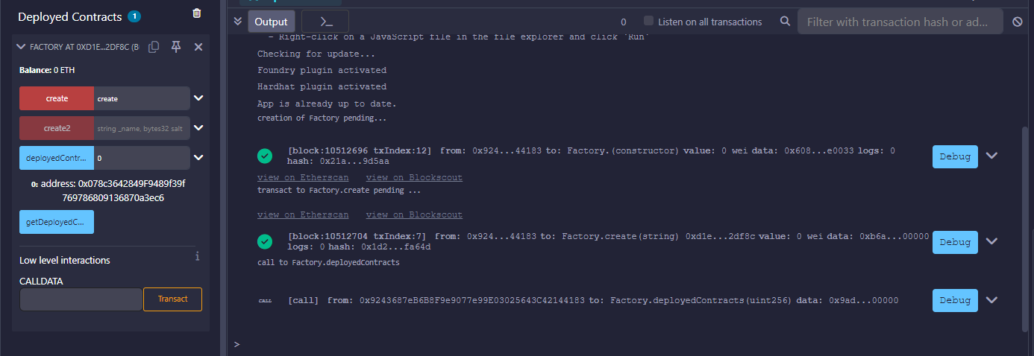
Contract two address: 0x8b27C7731591b821730bE8B6ad595057646FD5e2
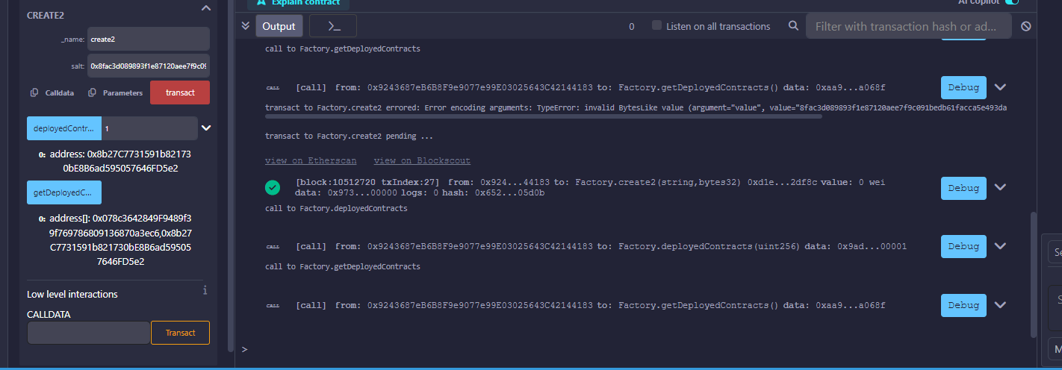
Gas comparison:
Gas cost using create: 307052 gas
Gas cost using create2: 291032 gas
